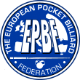
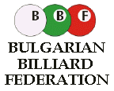
MAK MARKETING
WOULD LIKE TO INVITE FOR

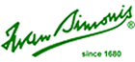




BULGARIA - BOURGAS

PRIZE MONEY – 3.820 EURO



1. PLACE - 1.100 EURO,
2. PLACE - 800 EURO,
3. PLACE - 400 EURO,
5-8 PLACES - 200 EURO,
9-16 PLACES - 40 EURO,

ENTRY FEE - 40 EURO
pupils and woman – 25 euro

Hotel: “Bulgaria” Bourgas
Single room (incl. breakfast) - 35 euro
Double room (incl. breakfast) - 20 euro per person,
Hotel booking: Vladimir Popov ,E-mail: real_billiard@abv.bg

ANOUCEMENT : mak@makmarketing.pl , biuro@bilard-sport.pl

Mak Marketing - Kielce- Poland - tel./fax +48 41 362-11-47 , 362-39-03.
Tournament director - Marcin Krzemiński - mobil + 48 602 196-206.

Sponsors :
Dynamic Billard Germany, Aramith, Simonis - Belgium, Sancioned by EPBF.

